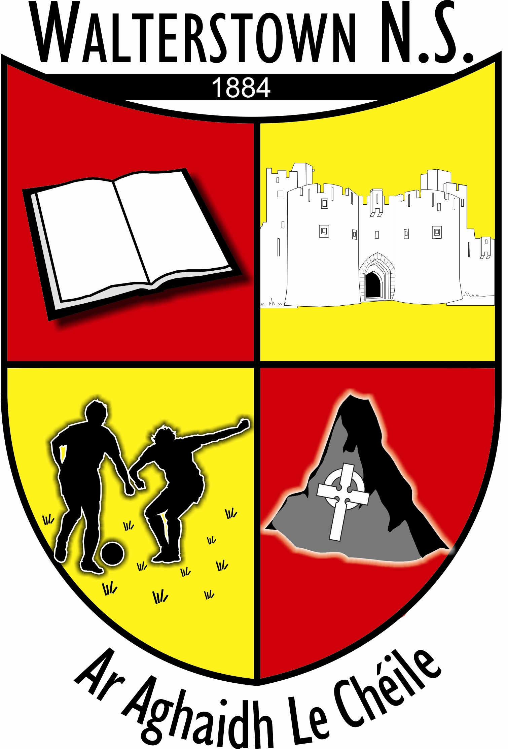

Walterstown N.S
Ar Aghaidh le Chéile

Child Profile
In accordance with GDPR Guidelines

1. Child’s name & surname: _________________________________

2. Class: _________________________________

3. Date of Birth: _________________________________

4. PPS number: _________________________________

5. Home address: _________________________________

_________________________________

_________________________________

6. Home telephone number: _________________________________

7. Mother’s / Guardian’s name: _______________________________

Mobile Number: _________________________________

Work number: _________________________________

E-mail: _________________________________

Occupation: _________________________________

8. Father’s / Guardians name: _______________________________

Mobile number: _________________________________

Work Number: _________________________________

E-mail: _________________________________

Occupation: _________________________________

9. Names of those who have permission to collect the child from school/ whom we can contact in case of emergency (Please ensure they are aware you have given us their details)

Name Home No. Mobile No

- _________________ _________________ _______________________

- _________________ _________________ _______________________

- _________________ _________________ _______________________

10. Family doctor: _________________ Telephone number: ________________

11. Allergies (e.g. penicillin)

_______________________________________________________________________

12. Long term illness (e.g. asthma, diabetes)

_______________________________________________________________________

Is your child on any long term medication?

_______________________________________________________________________

Other relevant information: e.g. history of dyslexia in the family.

_______________________________________________________________________

_______________________________________________________________________

13. Do we have permission to take your child to the doctor / hospital in case of emergency?
Yes: No:

14. (a) Does any legal order under family law exist that the school should know about?
Yes: No: Please provide details to the school.

Is your child living with?
Both parents one parent other
_______________________________________________________________________

Parents / Guardian signature (a) _______________________

Parents / Guardians signature: (b) ________________________

Date: ________________________

Behaviour Policy
This is to confirm that I/we have received, read and understand the Behaviour Code for Walterstown National School (See www.walterstownns.ie). We agree to abide by this Code and will work in co-operation with the School Staff and Authority to ensure that our child understands and abides by this code.

Signature: _______________________________

Acceptable Usage of the Internet
This is to confirm that I/we have read the Acceptable Usage of the Internet Policy of Walterstown National School and hereby agree to abide by the terms laid down therein.
Signature: _______________________________

School walks / Nature trails
This is to confirm that I/we give permission for my/our child to leave the school grounds with supervision to go on school related activities including walks / nature trails/ church visit etc.
Signature:_______________________________

Photographic Policy

I/we AGREE / DO NOT AGREE (Please circle your choice)

to allow the school or nominated persons to take photographs / videos of my/our child named below and give permission to have them published on the school website, school app newspapers and other publications / media / teacher parent communication apps. I/we understand that any photograph taken (and published) will be relevant to school activities only and taken by adults who have the authority to do so from the school authorities, and for whom the school has a record of official Garda clearance.
(Please note we have NO control over third parties, including parents/guardians, who may take photographs of pupils at school events held on the school premises or outside)

Signature: __________________________

Stay Safe Programme

I/we AGREE / DO NOT AGREE (Please circle your choice)

to allow my/our child named below to participate in the Stay Safe programme

Signature: __________________________________
I/we give our child/ children permission to make their own way home after school on:
Days: ________________________________________
_______________________________________
_______________________________________

Everyday
Screening tests are carried out in the school on all children from Infants to 6th Class. I allow my child to do these tests.
Parents Signature: ____________________________________

During your child’s time in Walterstown National School, it may be necessary from time-to-time for teachers to carry out diagnostic testing with your child on an individual basis in order to help them in their educational development. I give permission for any necessary diagnostic tests to be carried out with my child.
Parents Signature: ___________________________________

I give permission to allow my child to attend the Learning Support teacher following consultation with the parents / guardians if deemed necessary.
Parents Signature: ___________________________________

I give permission to allow my family details (name, address, date of birth, etc.) to be given to agencies such as HSE (school nurse, doctor, dentist).etc.
Parent Signature: _____________________________________
Both religion and ethnic and cultural background are considered sensitive personal data categories under Data Protection legislation. Therefore, it is necessary for each pupil’s parent/guardian to identify their child’s religion and ethnic background, and to consent for this information to be transferred to the Department of Education and Skills. All other information held on POD was deemed by the Data Protection Commissioner as non-sensitive personal data.
To which ethnic or cultural background group does your child belong (please tick one):
Categories are taken from the Census of Population: White Irish Irish Traveller Roma Any other White Background Black African Any other Black Background Chinese Any other Asian background Other (inc. mixed background) No Consent
What is your child's Religion: Roman Catholic Church of Ireland (incl. Protestant) Presbyterian Methodist, Wesleyan Jewish Muslim (Islamic) Orthodox (Greek, Coptic, Russian) Apostolic or Pentecostal Hindu Buddhist Jehovahs Witness Lutheran Atheist Baptist Agnostic Other Religions No Religion No Consent

DECLARATION
I/we have read and understand all aspects of this pupil profile and have replied honestly and accurately to all relevant sections, and have attached/enclosed all items requested therein. I/we hereby submit an application to Walterstown N.S for consideration:

(Child’s Name): ______________________________________
(Signatures)
Parent/Legal Guardian 1: _____________________________________
Parent/Legal Guardian 2: _____________________________________
(Date): __________________

GDPR Compliance: Walterstown N.S. is a data controller responsible for personal data - i.e. information relating to an identified or identifiable natural person. Walterstown N.S. processes personal data, i.e. the school collects, records, stores, retains and uses personal data. For further information please see our Data Protection Privacy Statement.

